R  Are | U  You | A  A | 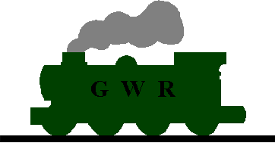  Steam Train | Nut
CAN YOU HELP TURN THIS
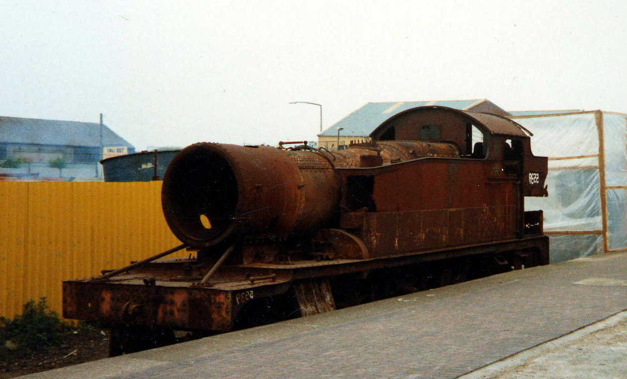
INTO THIS ?
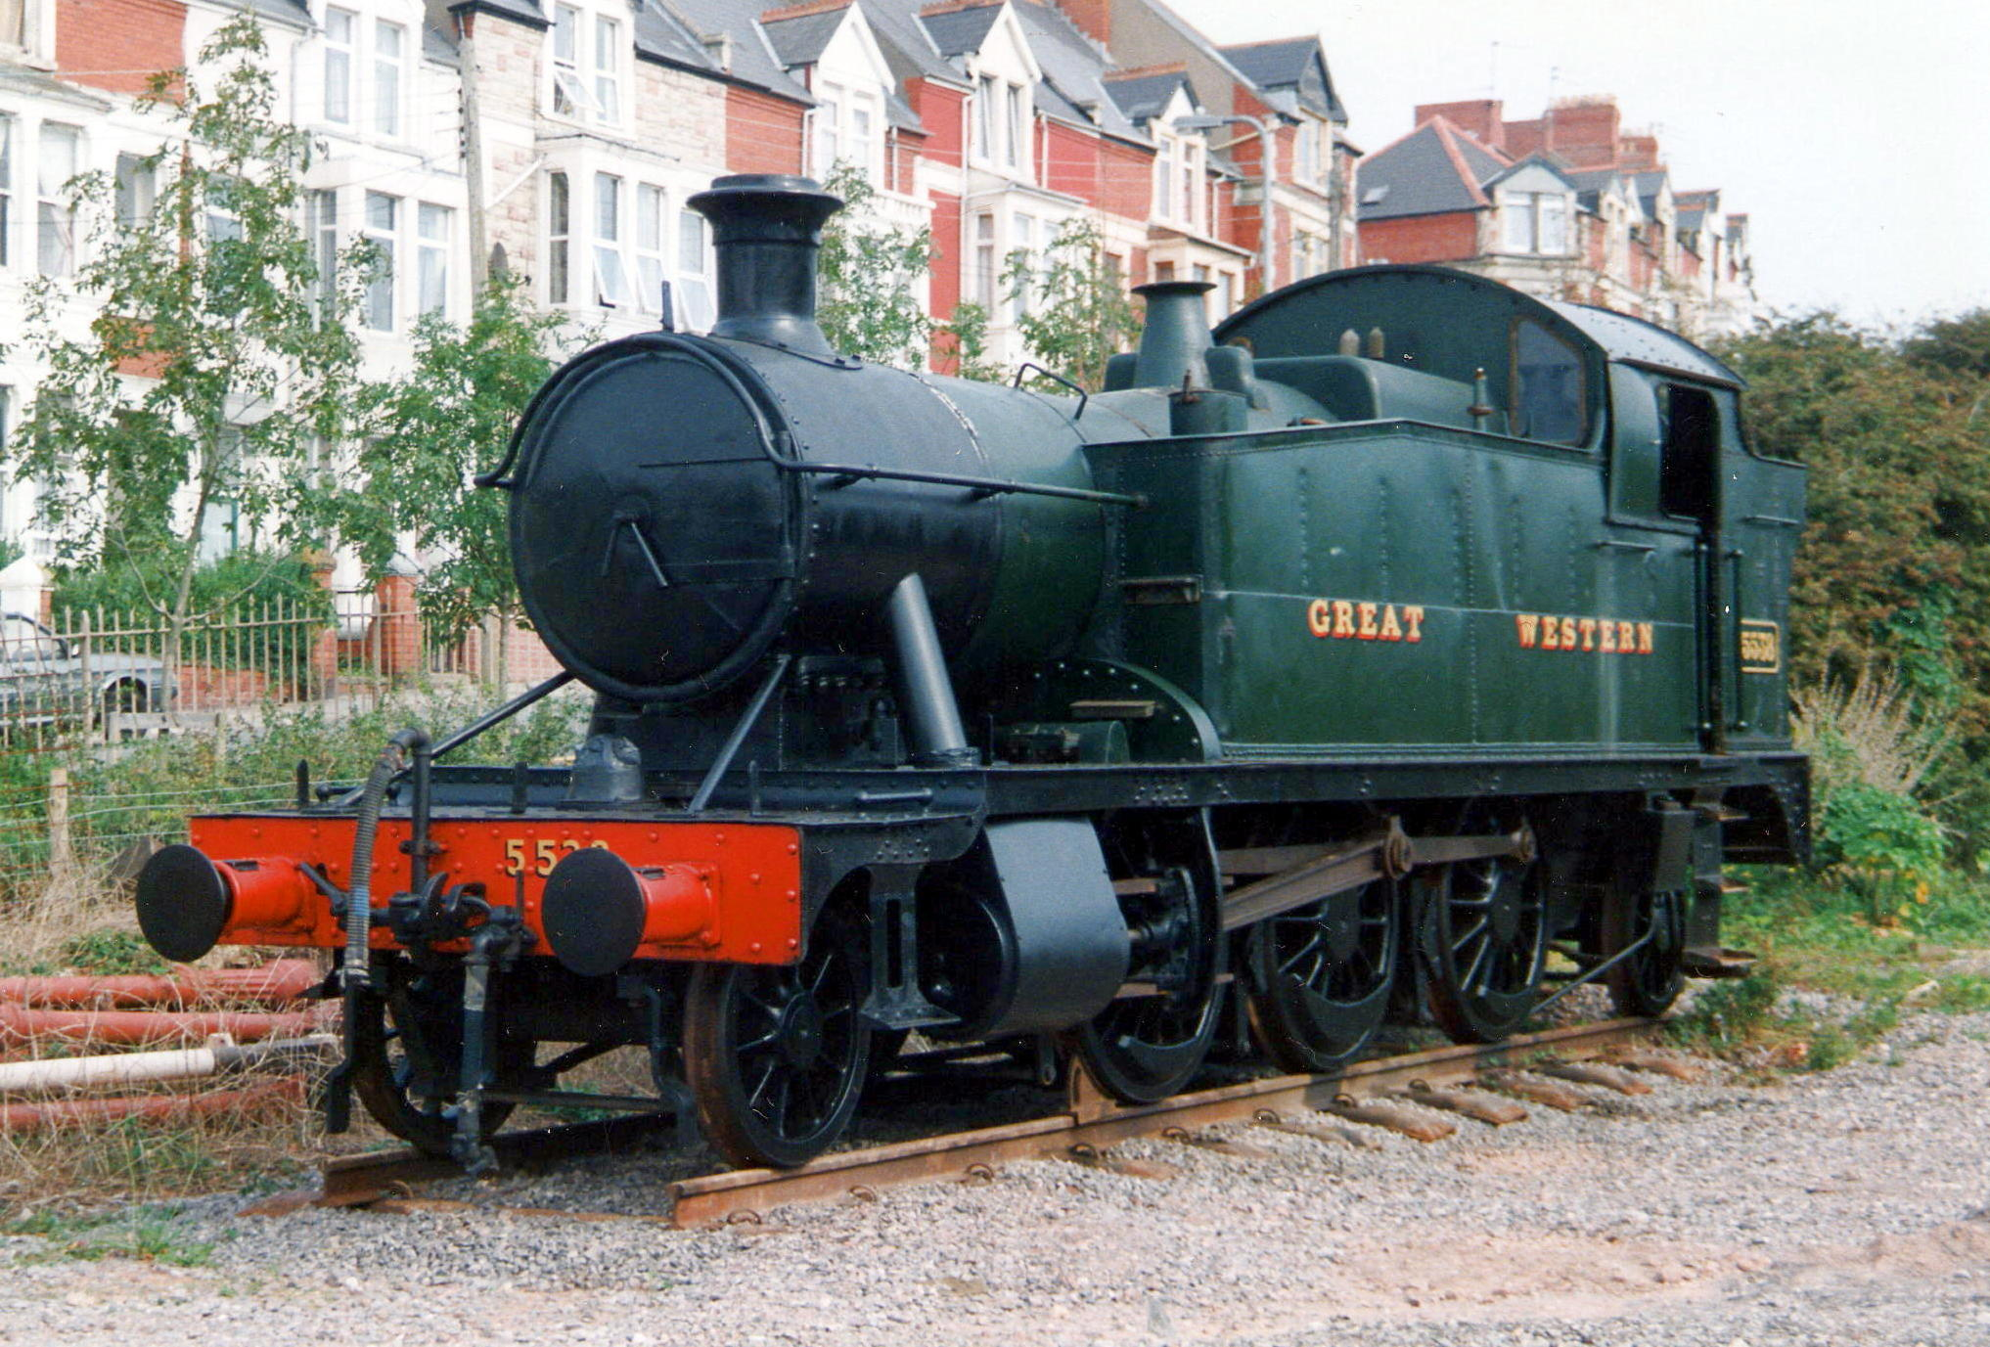
The Vale of Glamorgan Railway – Home of “The Barry Ten”

Welcome to The Vale of Glamorgan Railway & “The Barry 10", Dai Woodham’s last locomotives. The aim of this introduction is to provide everything you need to know about the last 10 steam locomotives to leave the legendary Dai Woodham's yard in Barry, South Wales. It is also intended to dispell the many rumours that have appeared in the Heritage Railway press over the years as to what what will become of these locomotives.

The locomotives were purchased in the late 1980s by the local Council with the intention of setting up the Wales Railway Centre. Unfortunately this plan did not come to fruition for numerous reasons & are now in the custody of the Vale of Glamorgan Railway pending restoration. The collection of locomotives known as the "Barry 10" are in fact 11. The 11th loco (Small Prairie 5538) was gifted to the town of Barry by Dai Woodham to display on the seafront of Barry Island & as with the other 10 is now under the custody of the VoGR.

The year 2002 will be the start of a very bright future on many fronts for the VoGR. In January they were awarded 2 separate grants to complete the Hood Road goods shed & platform & to build another line past the original Barry Railway loco shed into Barry Town itself. It is also hoped that restoration will start on the elusive locomotives with a number of fundraising schemes being worked out to get people involved. These schemes will then be publicised in various ways such as the heritage press & the website (http://vogr.org)

It is expected that the first loco to be tackled is the Small Prairie which in this case will in fact involve 2 sister engines (5538 & 5539). One of the locomotives is minus a boiler but has a good frame whereas the other has a reasonable boiler but a bent frame. It is therefore expected that one loco will be built from the best of both with the remains assembled as a static exhibit as originally intended by Dai Woodham. In time there will always be the prospect of restoring this loco but for now there is more than enough work to be done on the other locomotives to concentrate on that are far closer to returning to steam.

So what can you do ? Firstly you can join the Society as this one fact alone is key to unlocking possible grant funding. Of all the locomotives rescued from Woodham’s yard many of the ones currently working around the country would still be a pile of scrap if it were not for grants & donations. However, in virtually all cases the grants are match-funded. This means that the membership figures are taken into account in the form of labour time with an equivalent value being made up by the grant. In simple figures we currently have a membership of around 250 members so if a figure of say £10 per hour was valued against each member’s labour, an equivalent figure could be granted therefore turning £2,500 into £5,000. So the more members we have the better chance we have of restoring these forgotten locomotives sooner. Only you can make a real difference.

To help in this huge project I am appealing for photographs, facts & information relating to the collection for display on this site. If anyone has something that you believe the project could benefit from please contact me.

For further details on the locomotive collection please take a look at http://vogr.org. This web site will be developed & maintained as the internet home of the “Barry 10” & serve as the base point for all related projects, appeals & news. By joining the society you will also receive newsletters & journals to keep you informed on developments & free member tickets.

SO JOIN NOW & MAKE A DIFFERENCE.

